**Name – Om Atul Mahadeokar**

**Roll no. – 18**

**SRN – 202200340**

**Div – B**

**Batch – B1**

**Assignment 5**

**SQL Injection Attack**

**First Username and password used is -   
username – worm  
Password - 1234**

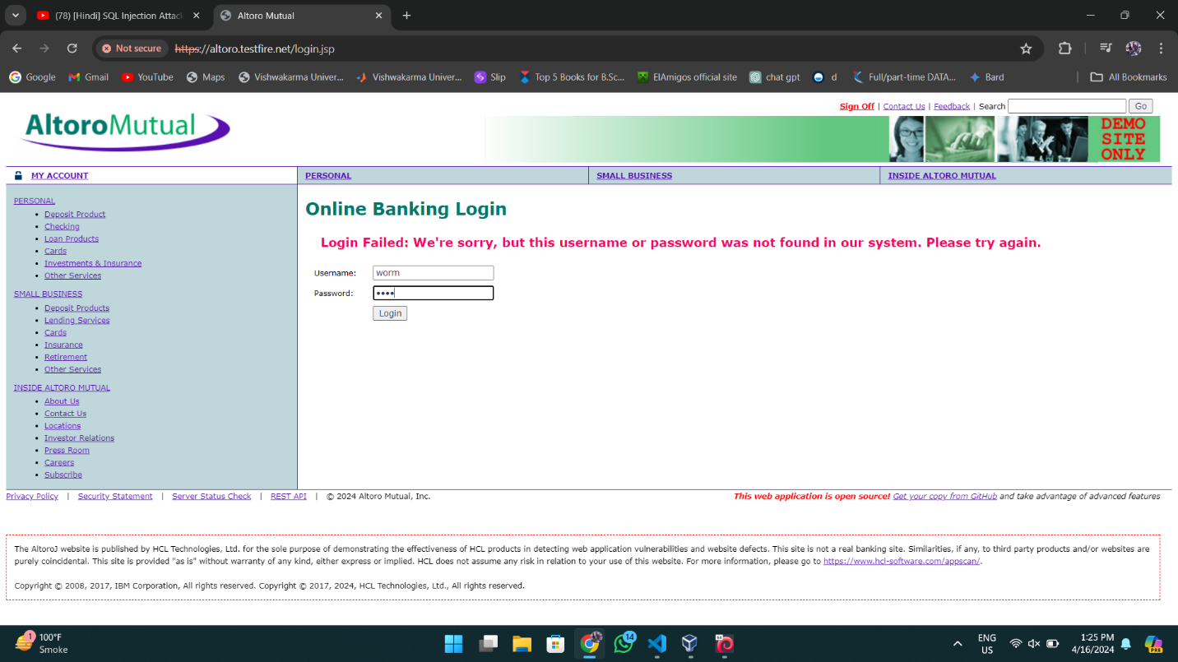

**So it displays the error that -  
Login Failed: We're sorry, but this username or password was not found in our system. Please try again.**

**Now using the SQL injection Attack -   
username - ‘OR 1=1—**

**Password – 1234  
  
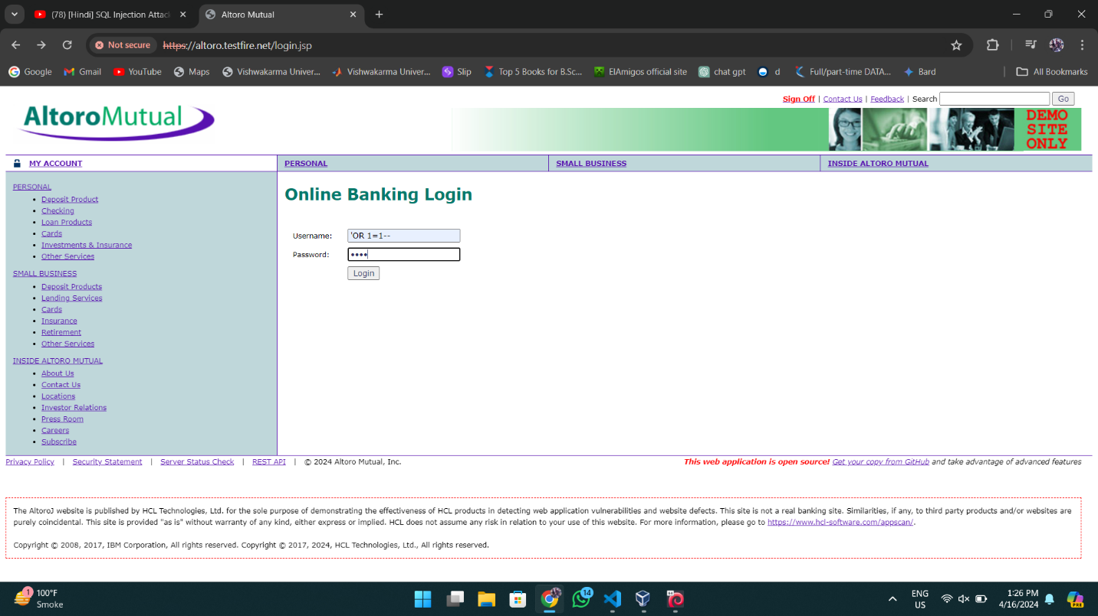**

**It bypasses the validation due to the SQL Query**

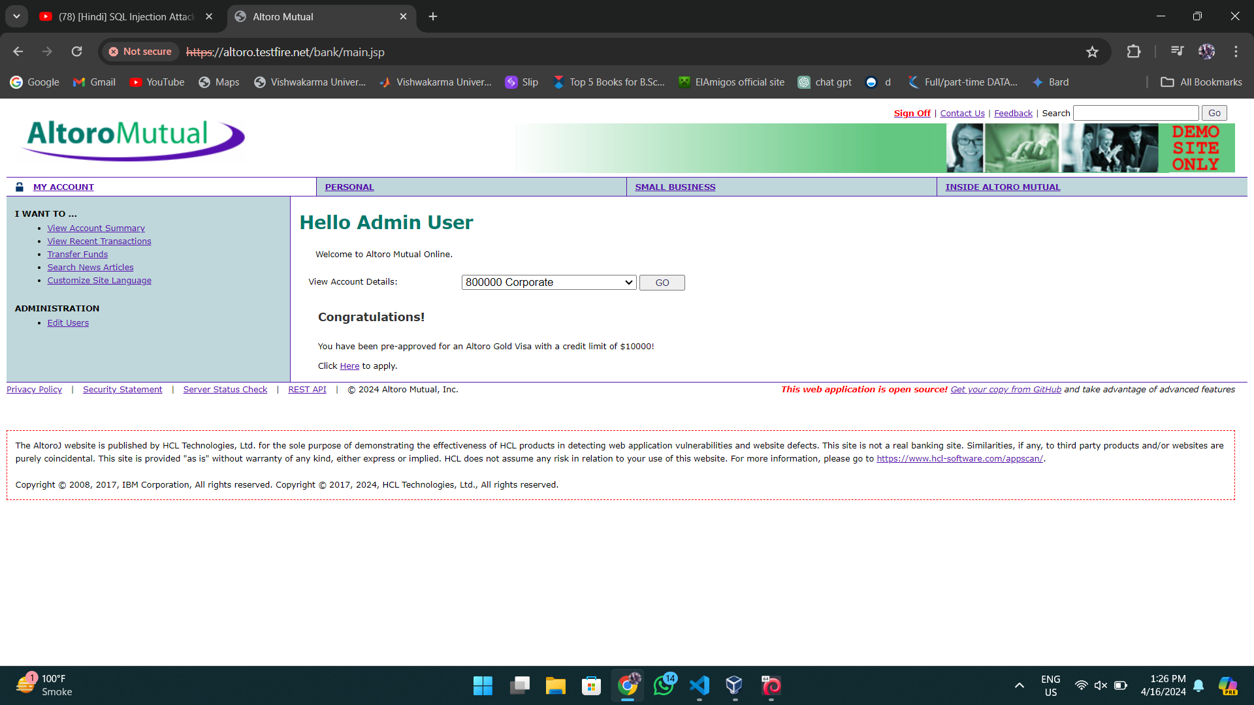

**SQL – sqlmap**

